**B.M.S. COLLEGE OF ENGINEERING BENGALURU**

Autonomous Institute, Affiliated to VTU



Lab Record

**Object-Oriented Modeling – 23CS5PCOOM**

*Submitted in partial fulfillment for the 5th Semester Laboratory*

Bachelor of Engineering

in

Computer Science and Engineering

*Submitted by:*

**POOJA C HADLI**

1BM23CS232

Department of Computer Science and Engineering

B.M.S. College of Engineering

Bull Temple Road, Basavanagudi, Bangalore 560 019

August 2025-December 2025

**B.M.S. College of EngineerinG**

**DEPARTMENT OF COMPUTER SCIENCE AND ENGINEERING**

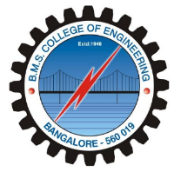

***CERTIFICATE***

This is to certify that the Object-Oriented Modeling(23CS5PCOOM) laboratory has been carried out by POOJA C HADLI (1BM23CS232) during the 5th Semester August 2025-December 2025

.

Signature of the Faculty Incharge:

Dr Adarsha Sagar H V

Assistant Professror

Department of Computer Science and Engineering

B.M.S. College of Engineering, Bangalore

Table of Contents

|  |  |  |
| --- | --- | --- |
| **Sl. No.** | **Experiment Title** | **Page No.** |
| **1** | Hotel Management System | 4-9 |
| **2** | Credit Card Processing | 10-15 |
| **3** | Library Management System | 16-21 |
| **4** | Stock Maintenance System | 22-27 |
| **5** | Passport Automation System | 28-33 |

1. Hotel Management System

SRS Document:

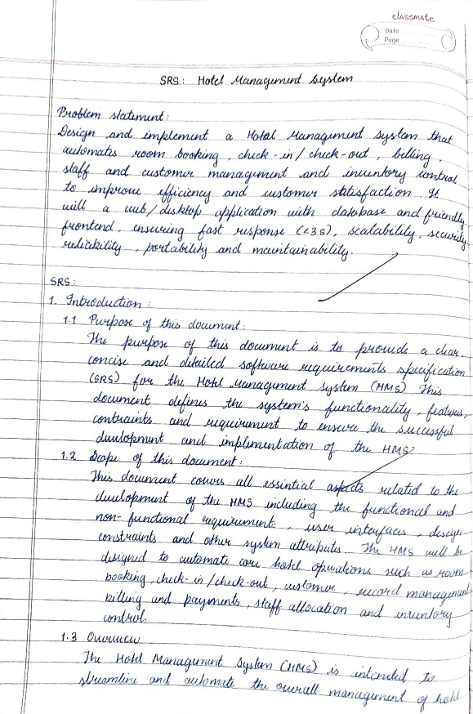 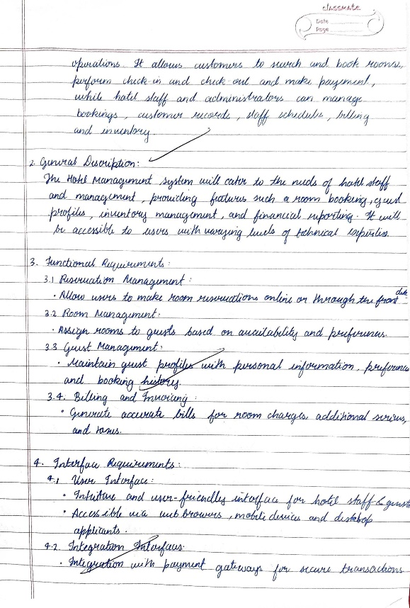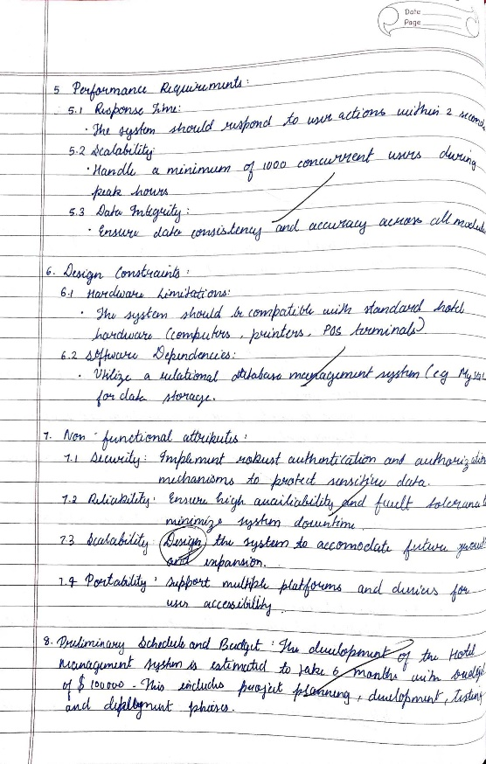

Class Diagram

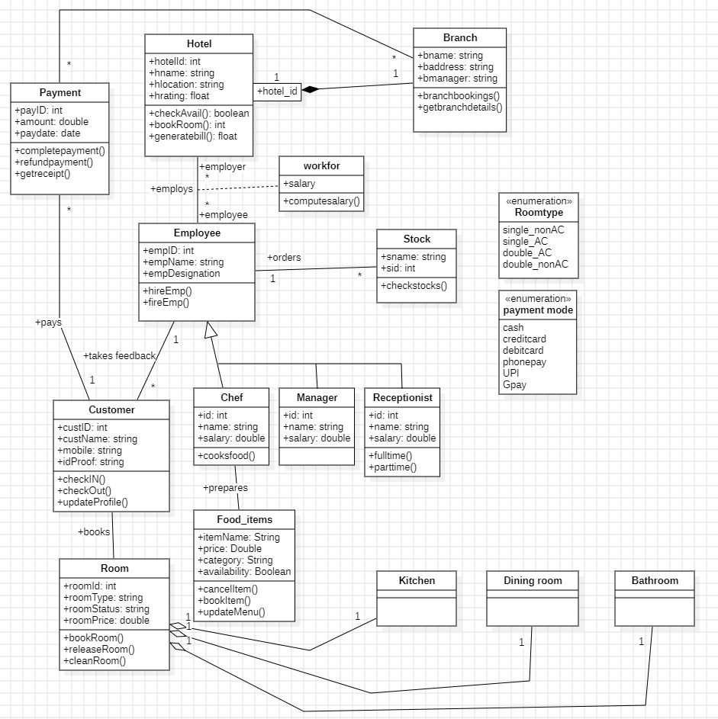

State Diagram:

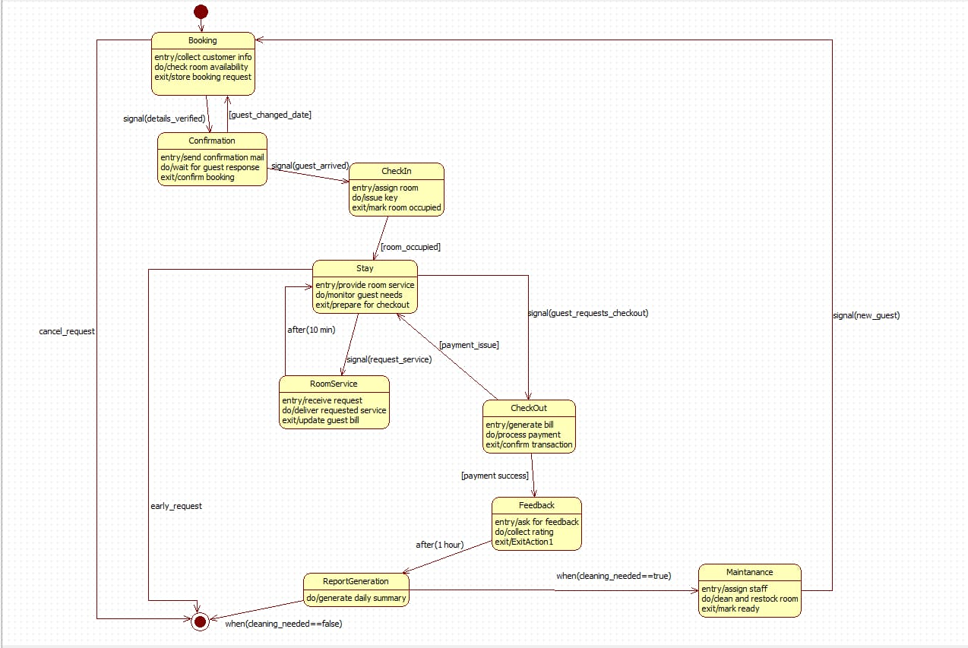

Use-Case Diagram:

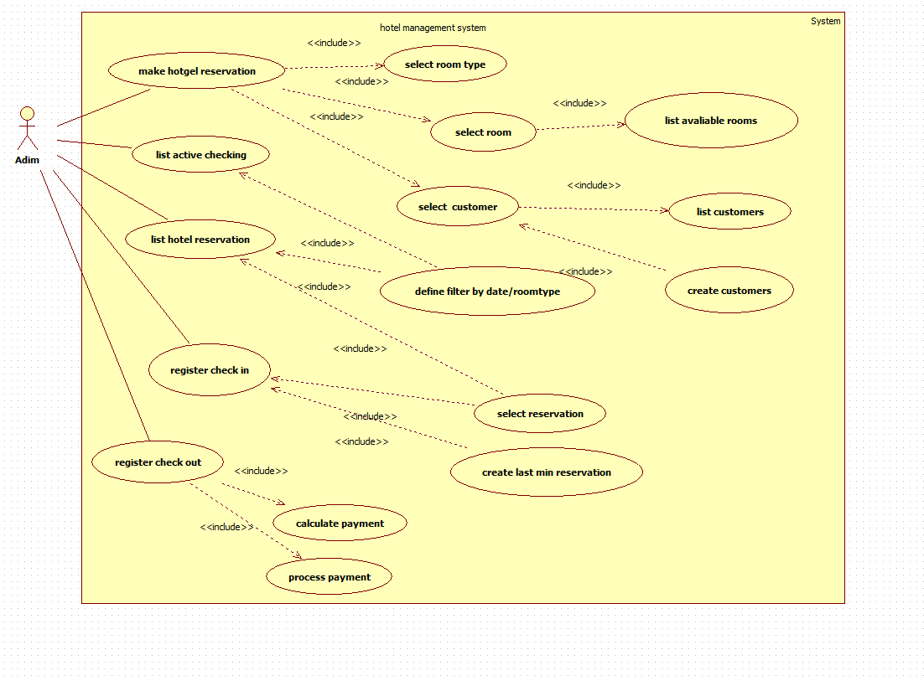

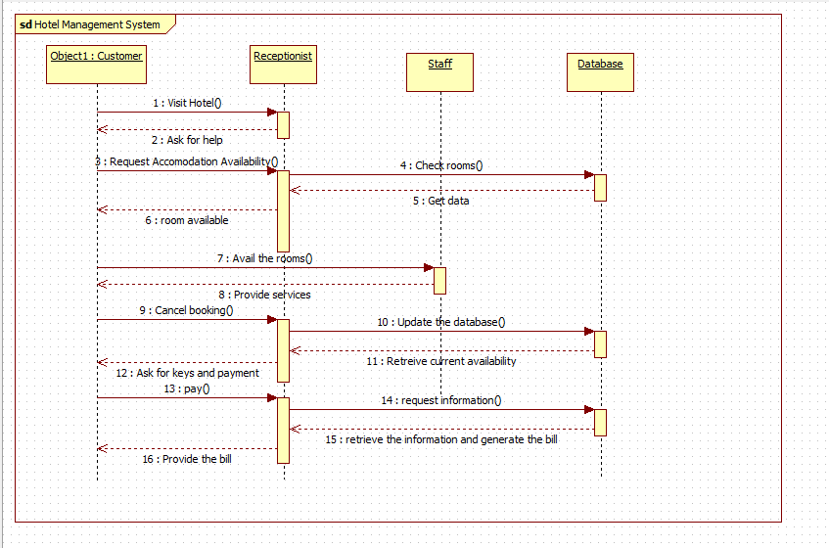Sequence Diagram:

Activity Diagram:

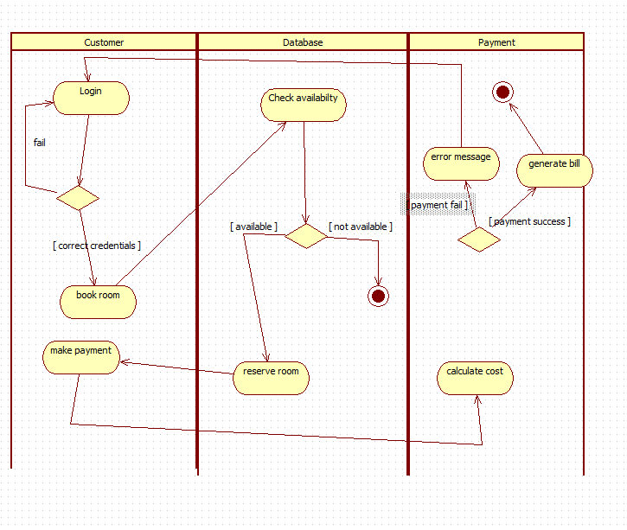

2. Credit Card Processing

SRS Document:

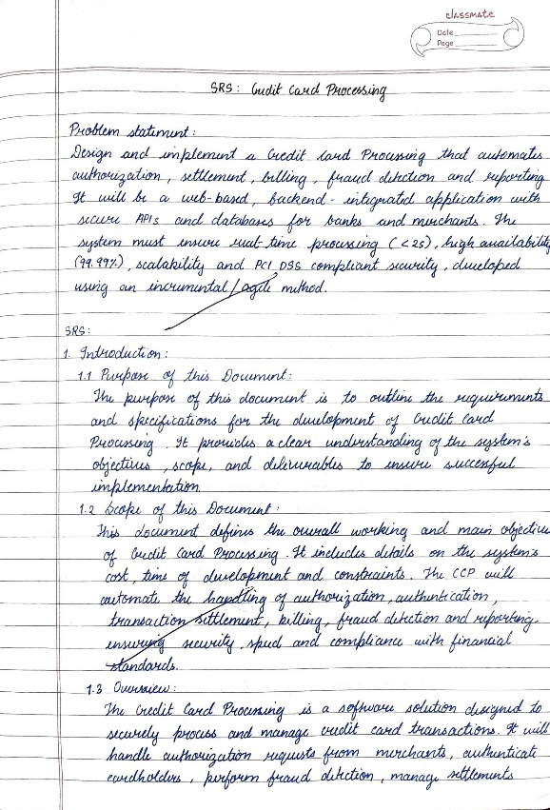 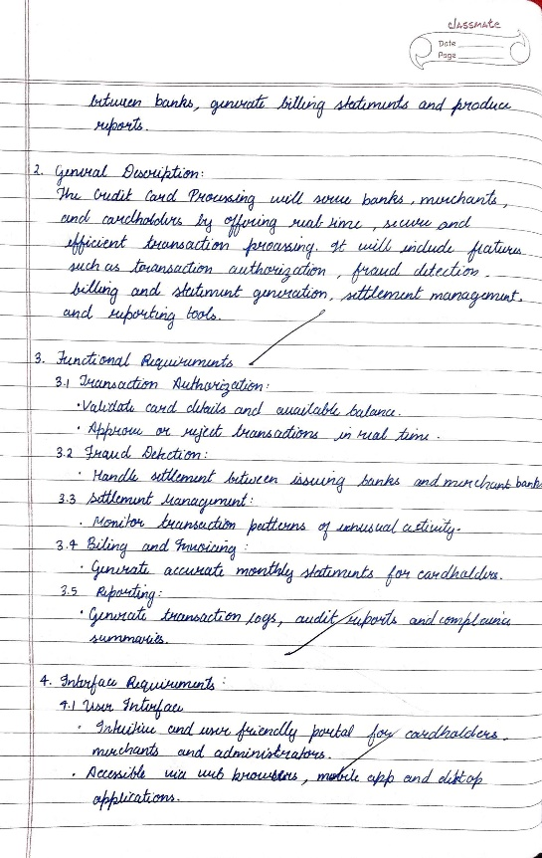

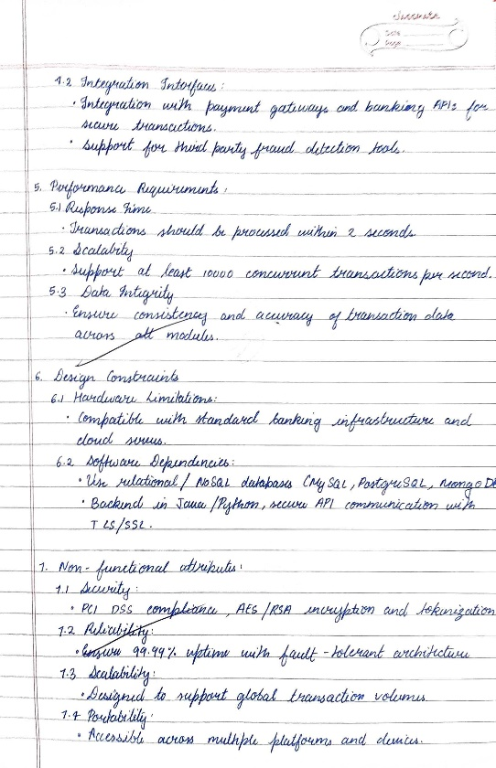 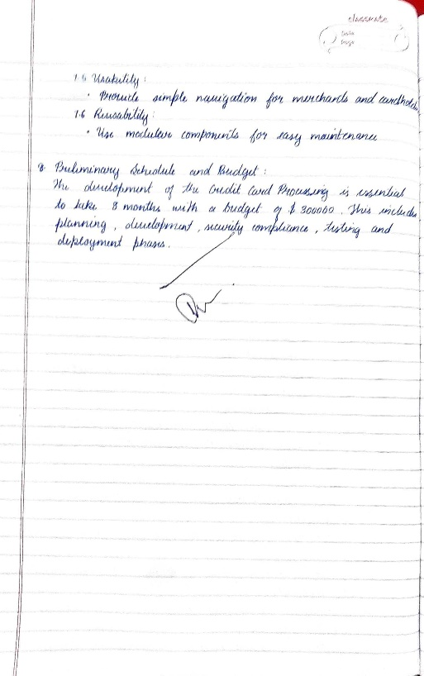

Class Diagram:

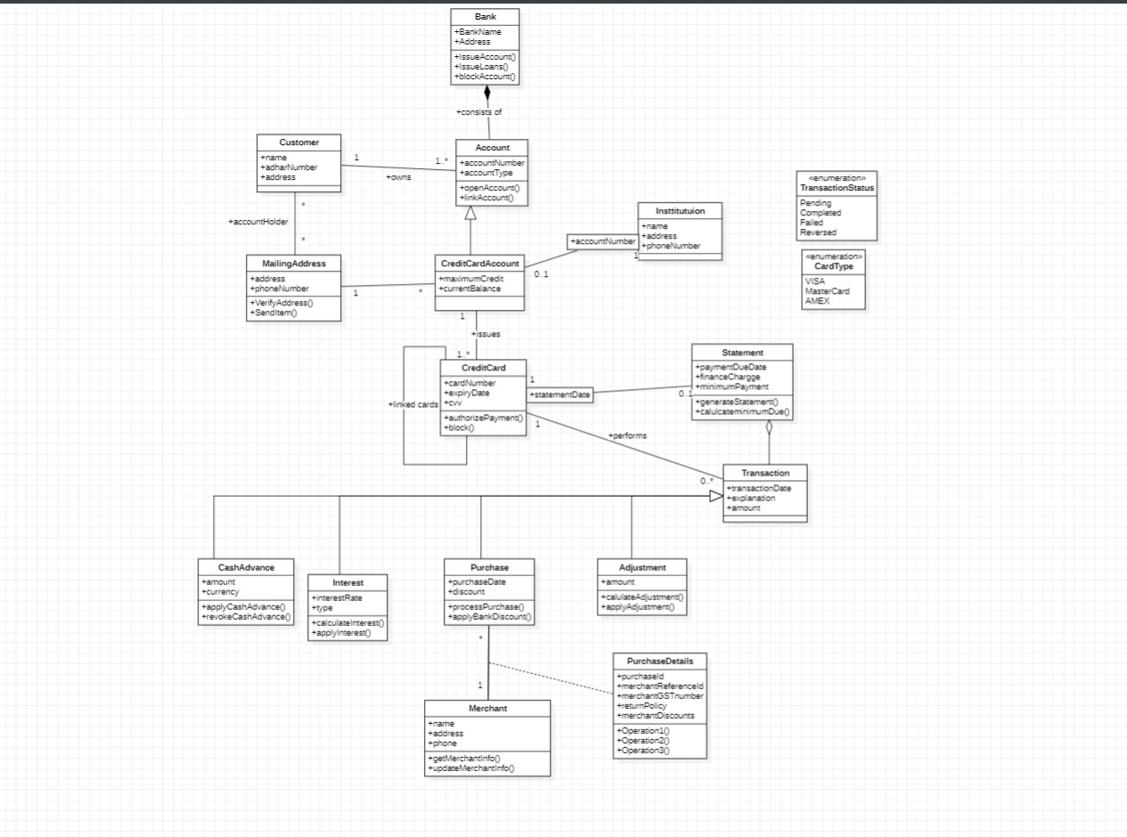

State Diagram:

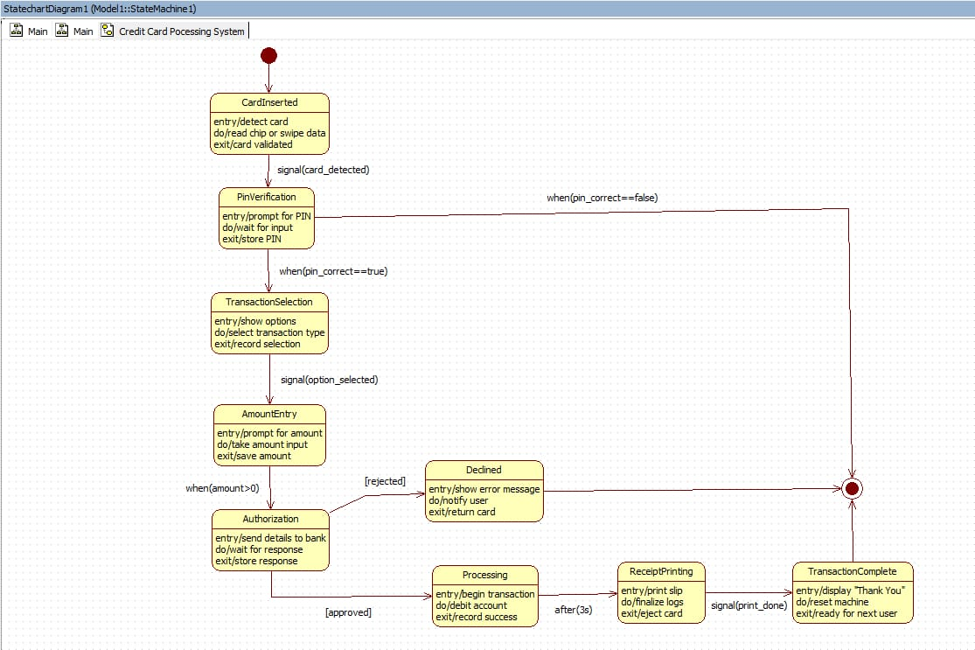

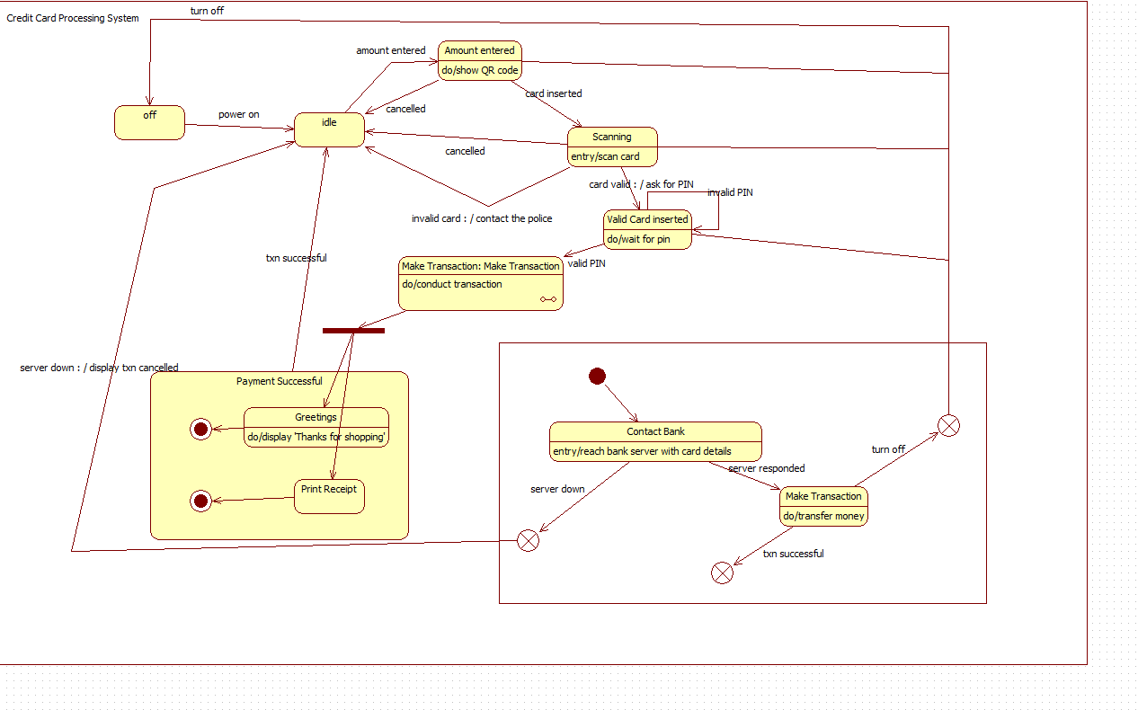

Use-Case Diagram:

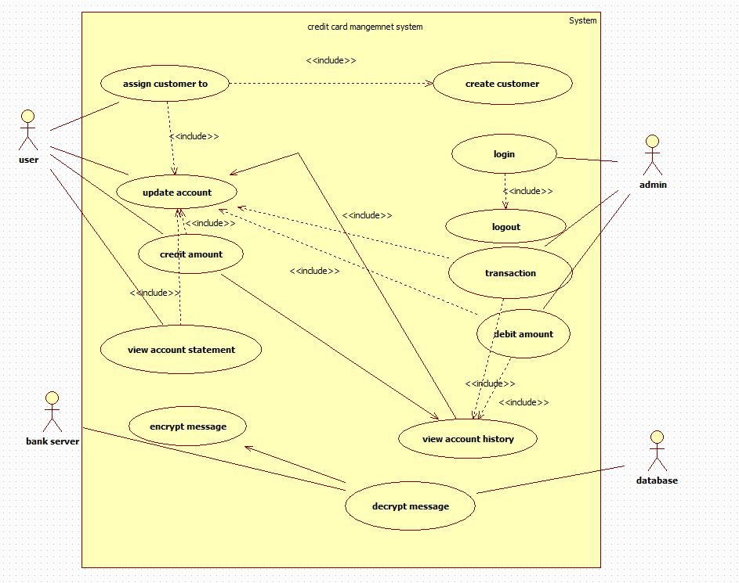

Sequence Diagram:

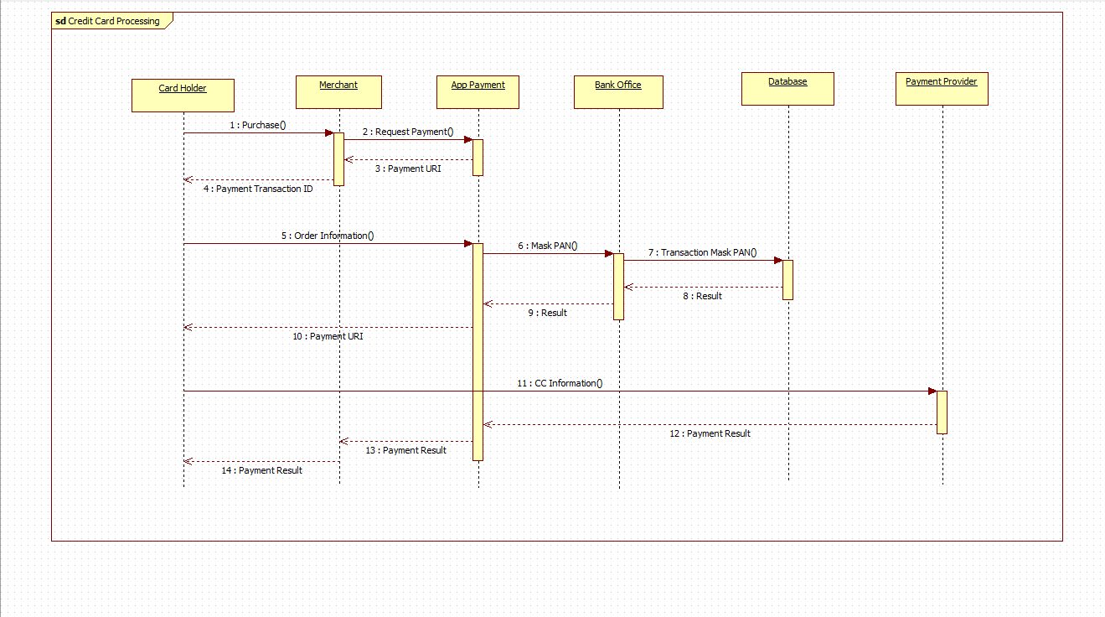

Activity Diagram:

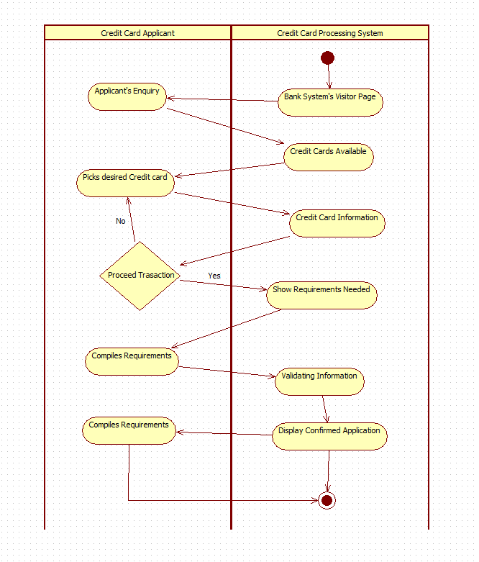

3. Library Management System

SRS Document:

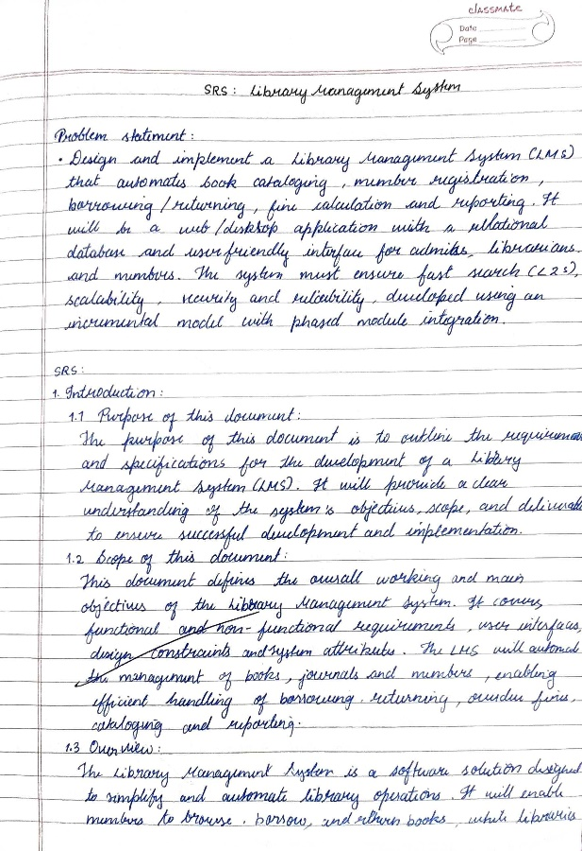 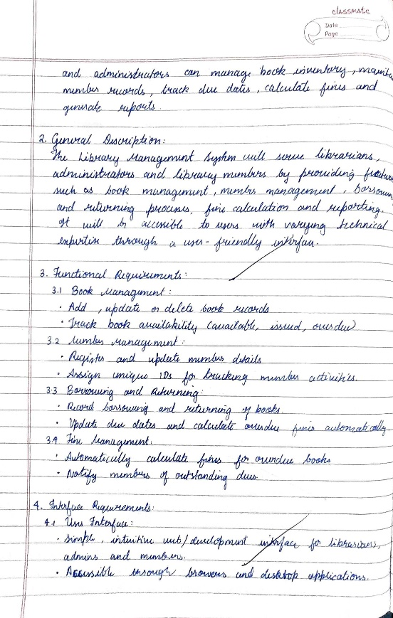

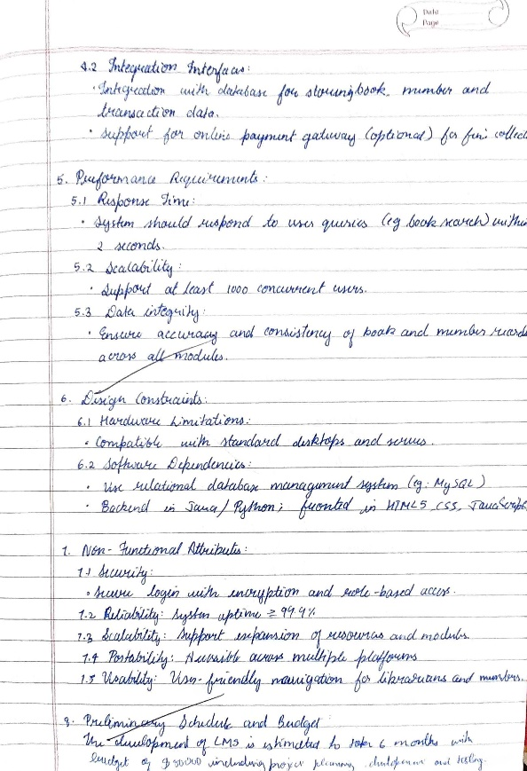

Class Diagram:

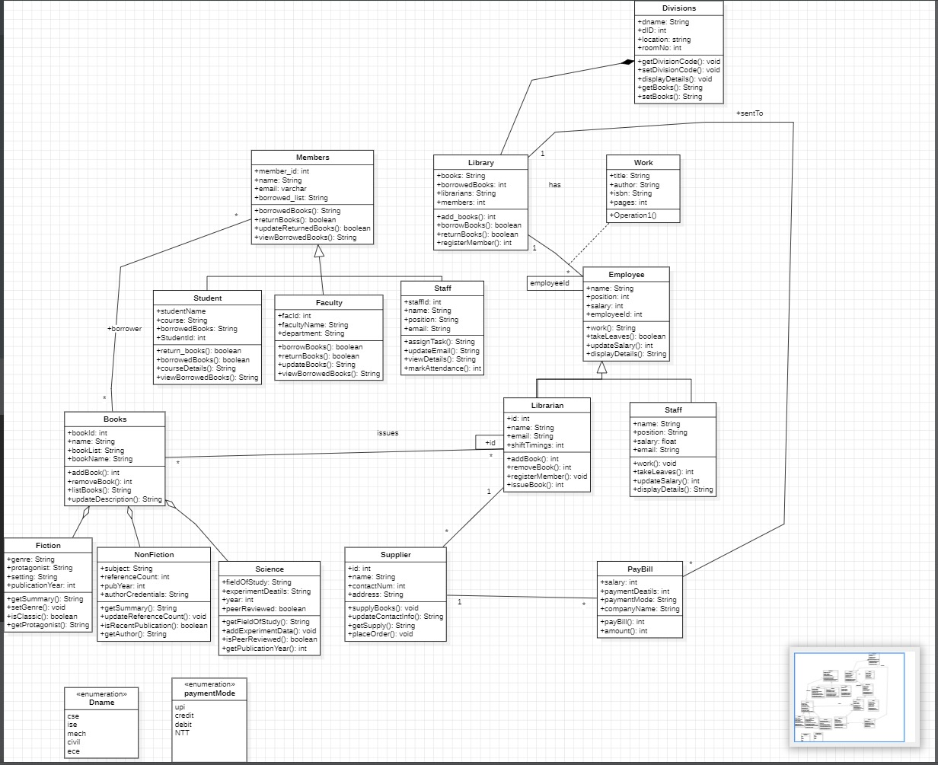

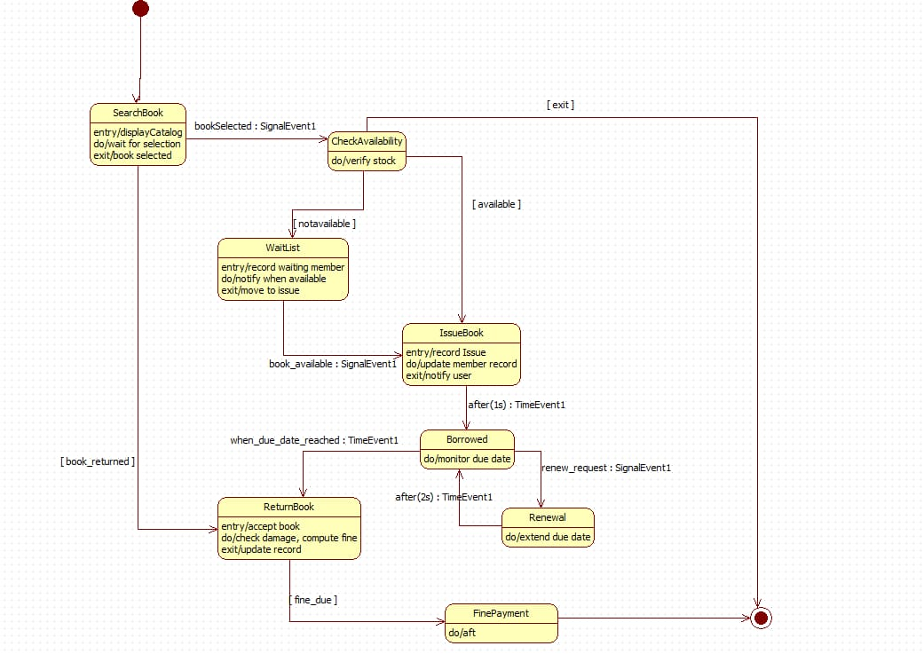State Diagram:

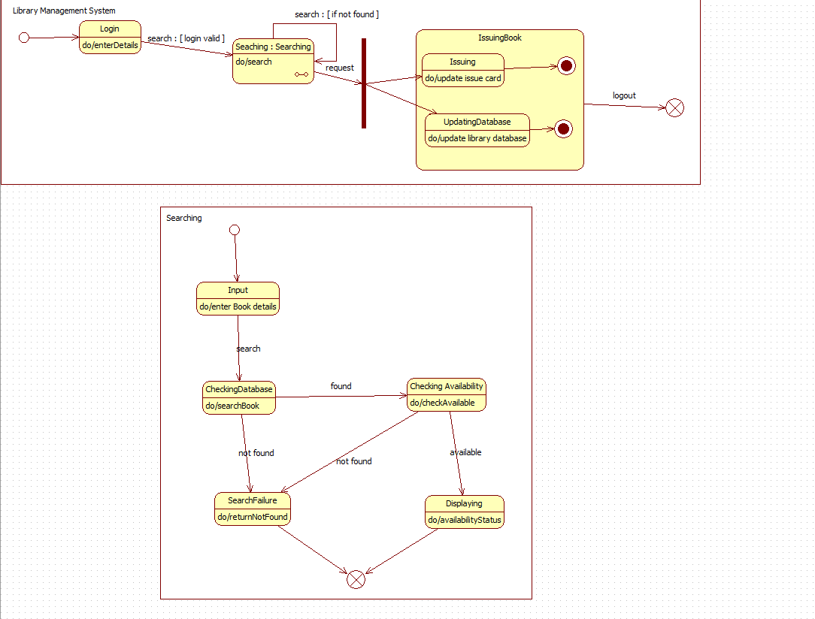

Use-Case Diagram:

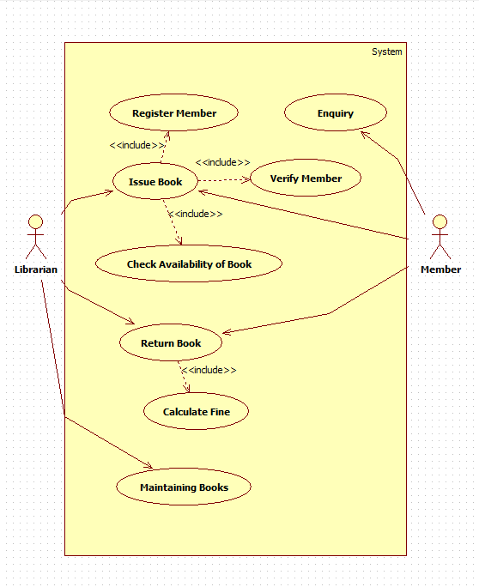

Sequence Diagram:

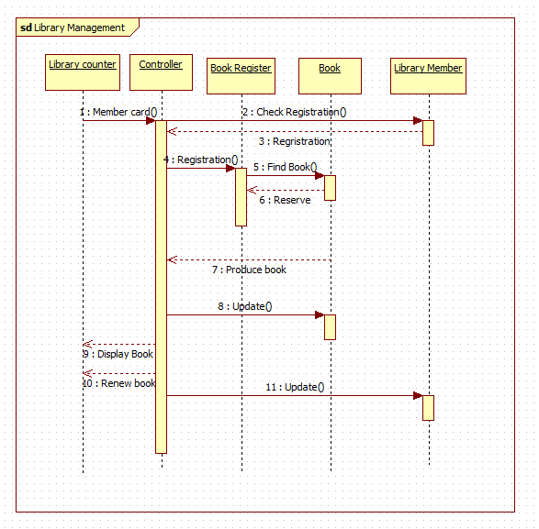

Activity Diagram:

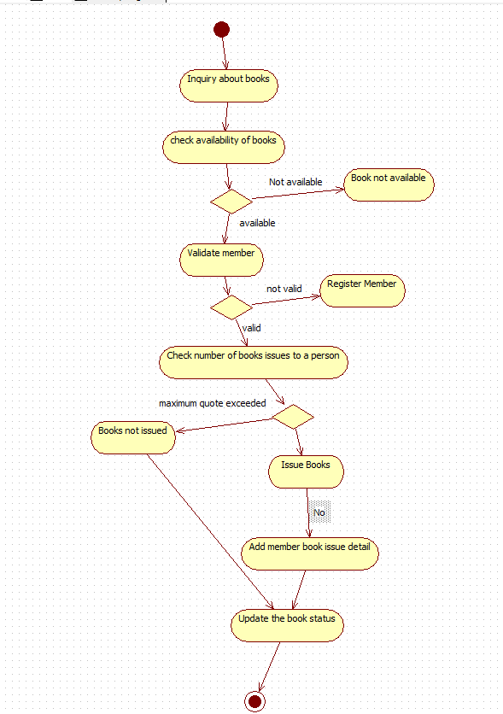

4. Stock Maintenance System

SRS Document:

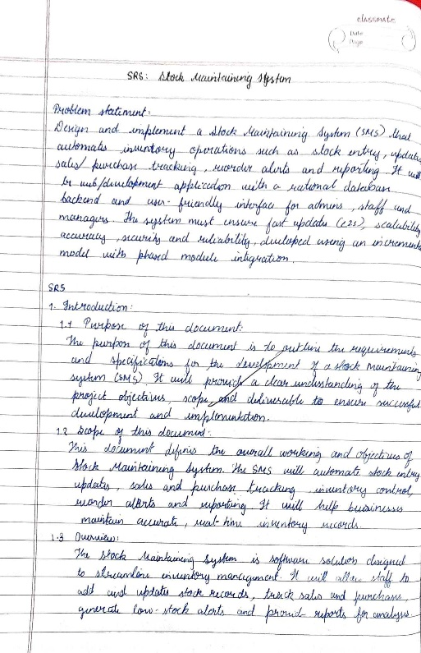 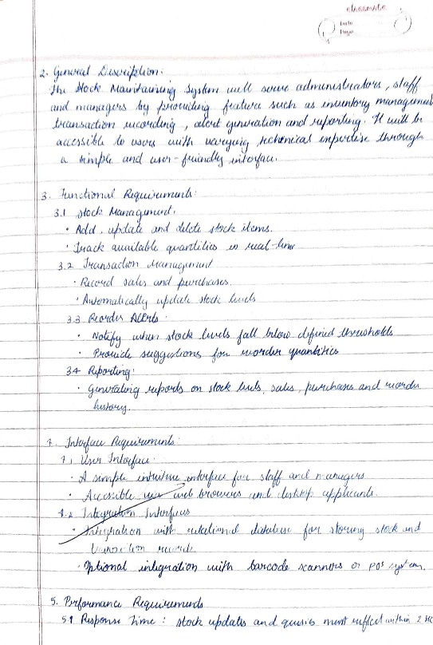

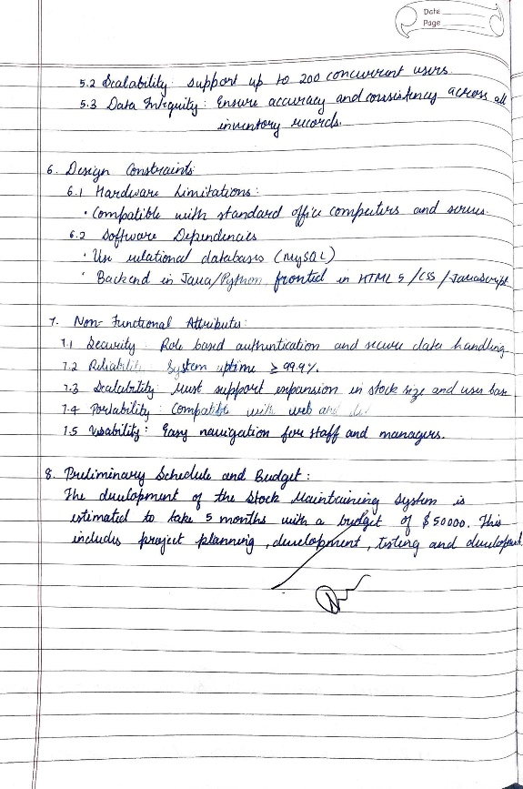

Class Diagram:

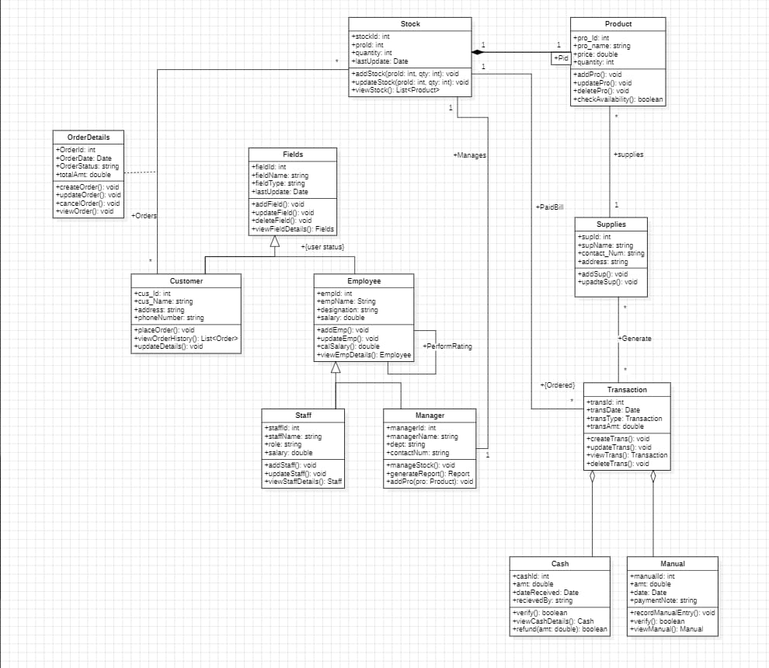

State Diagram:

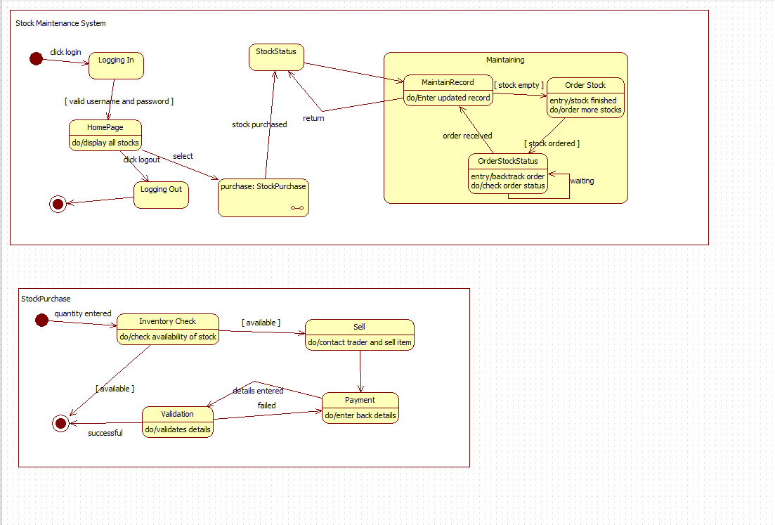

Use-Case Diagram:

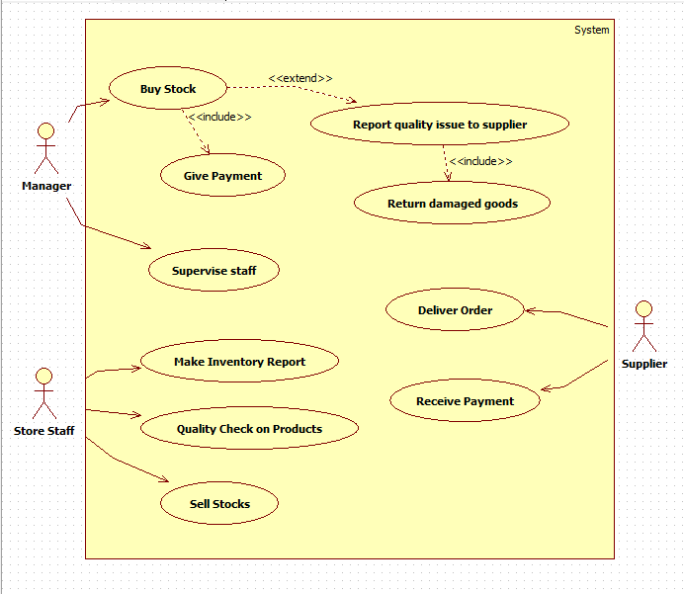

Sequence Diagram:

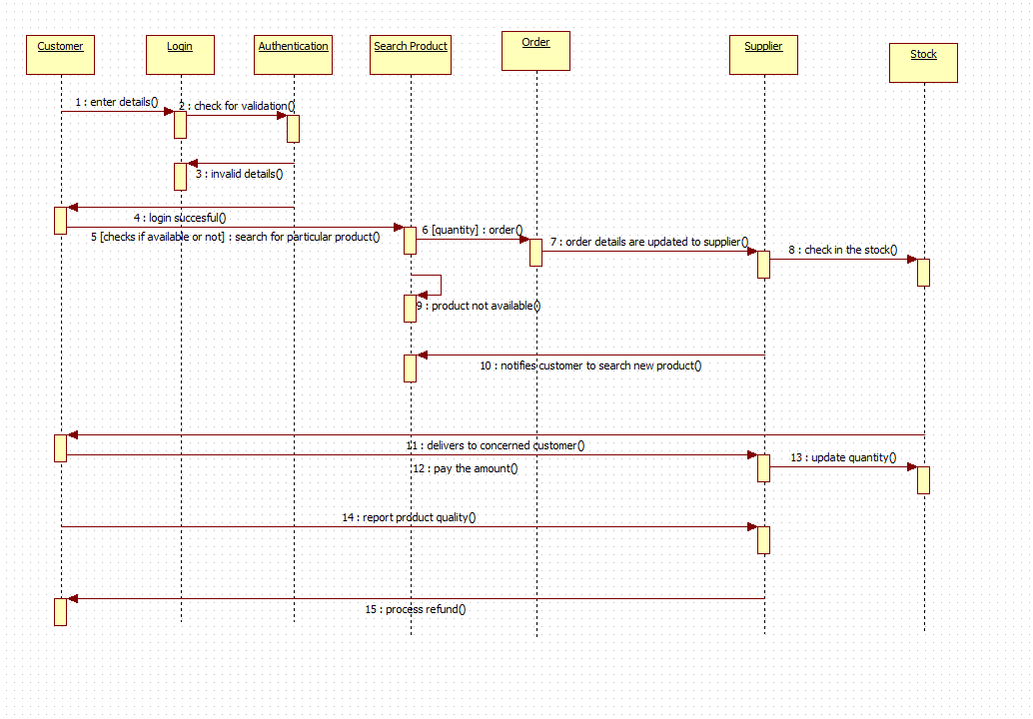

Activity Diagram:

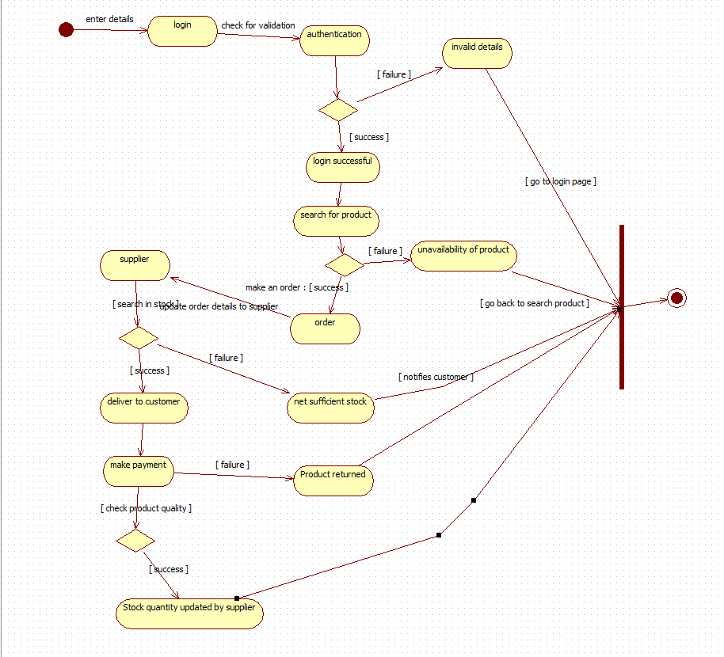

5. Passport Automation System

SRS Document:

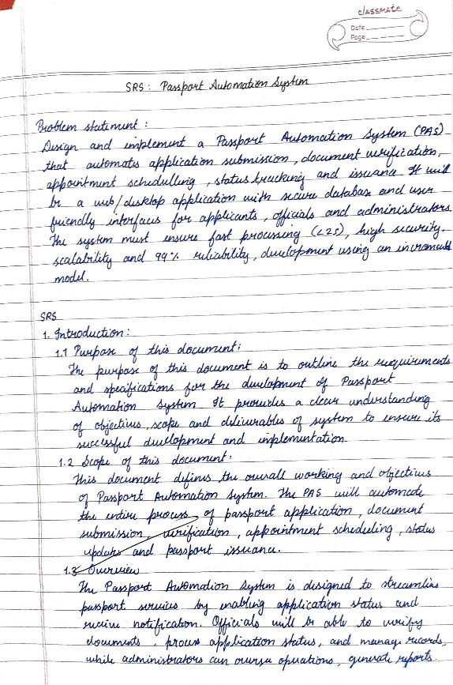 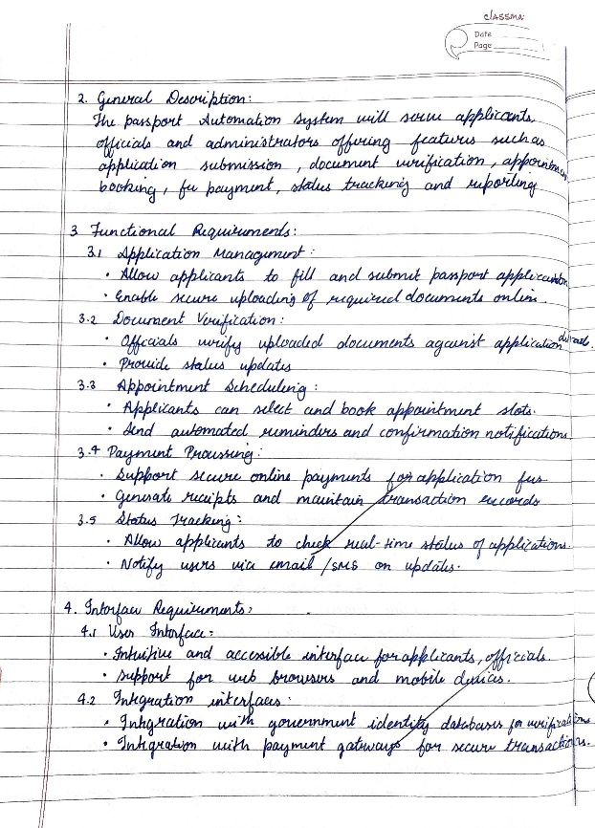

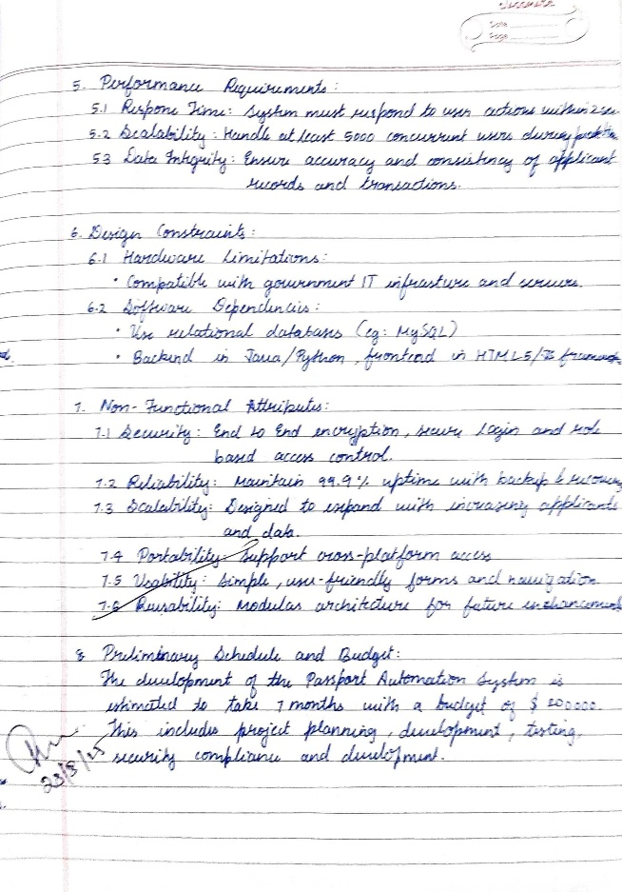

Class Diagram:

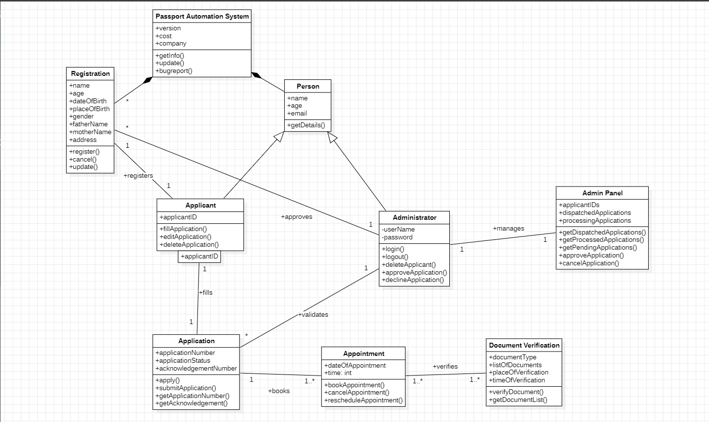

State Diagram:

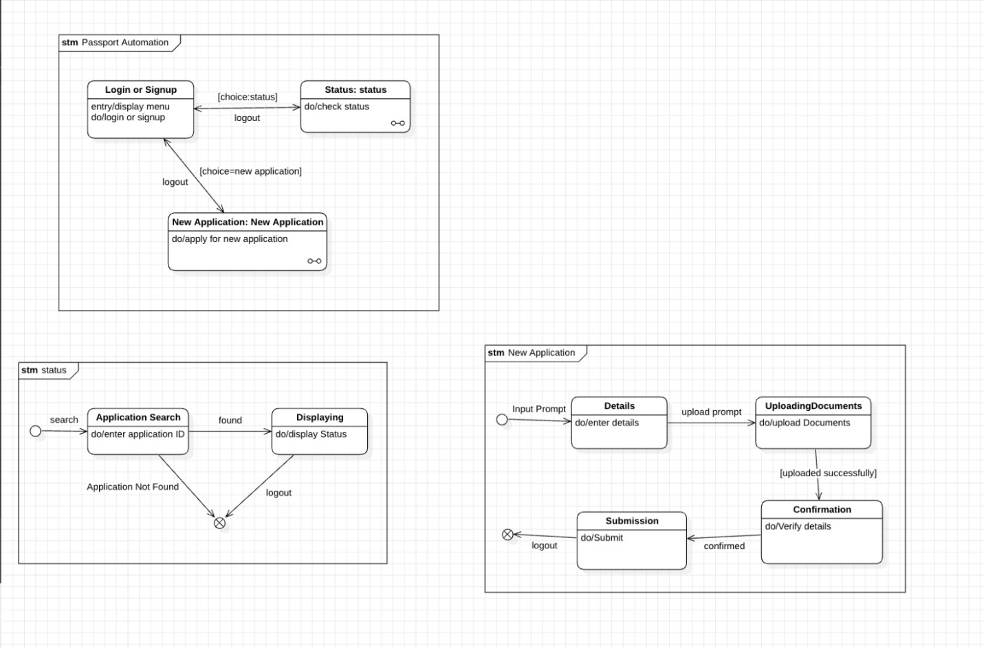

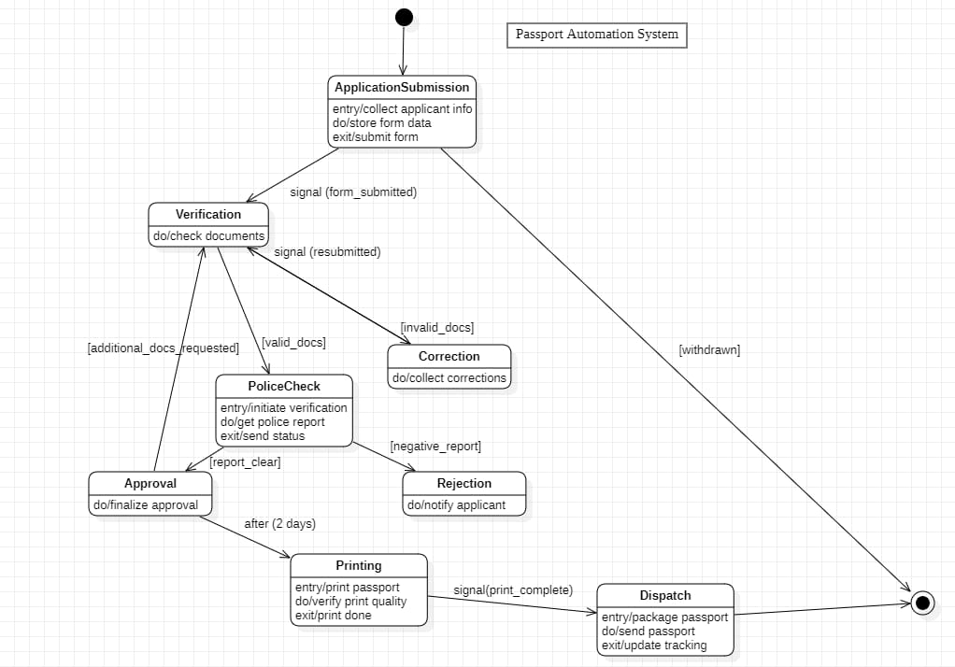

Use-Case Diagram:

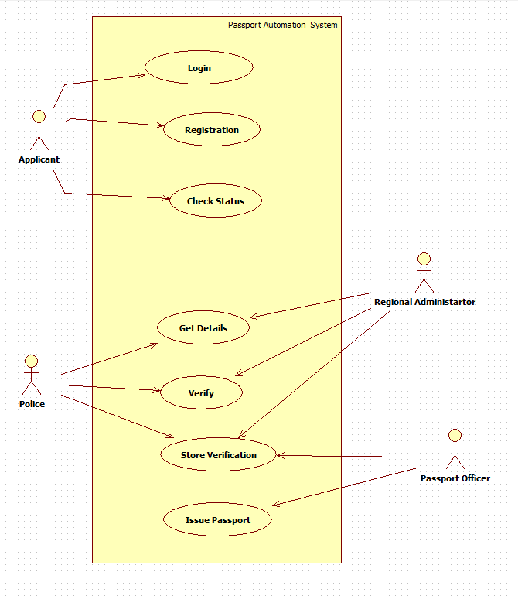

Sequence Diagram:

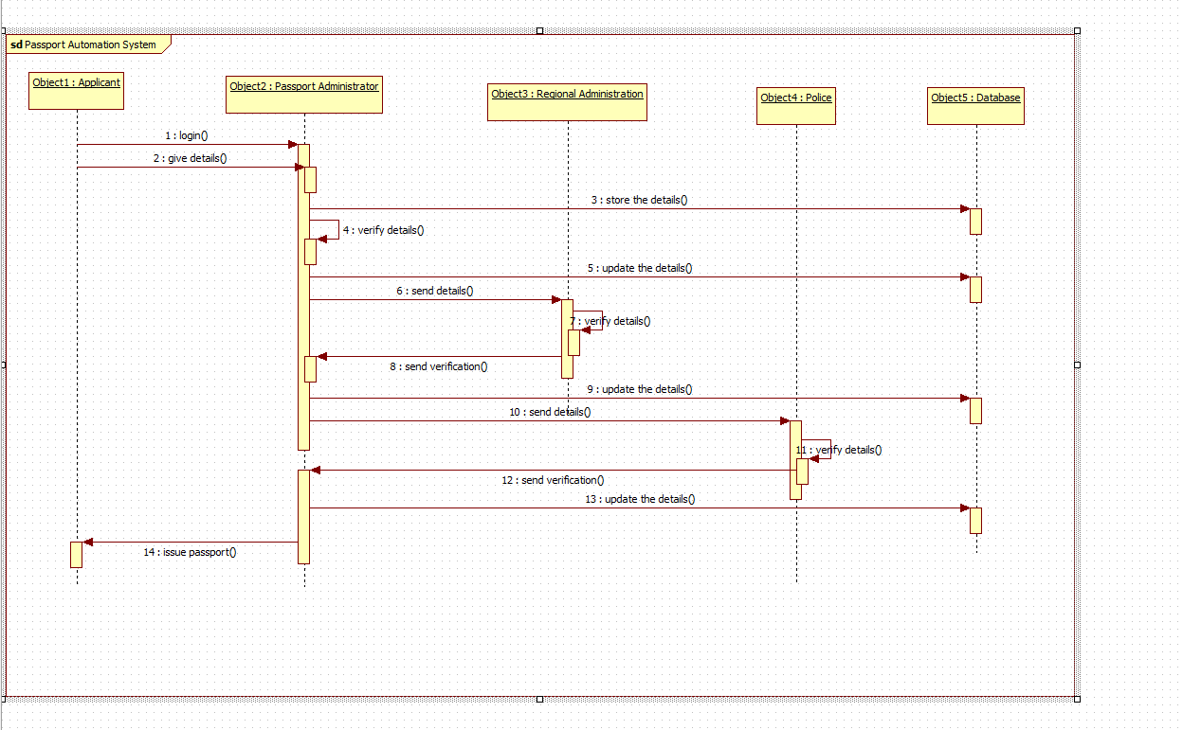

Activity Diagram:

